The Ropley Society

Annual General Meeting
Ropley Parish Hall
Thursday 21st April 2022 @ 7.30pm

We are delighted that renowned local historian Jane Hurst will join us for the first part of the evening to take us on a walk around Jane Austin’s Alton. Jane (Hurst) will share with us pictures of the Alton that Jane (Austin) and her family would have known at the time
Jane Austin’s Alton
How much would she recognise if she were to return today ?

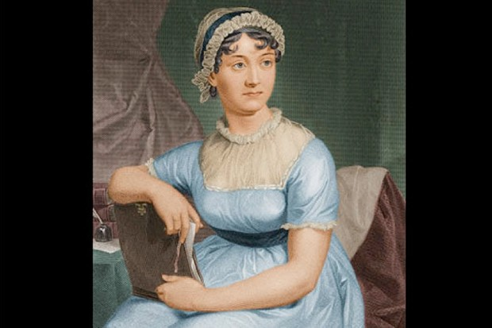

To be followed by the formal business of the 2021 AGM
AGM Agenda

- Apologies for absence and introductions.
- Approval of Minutes of AGM held on 15th April 2021 and matters arising.
- Chairman’s Report
- Hon Treasurers Report
- Membership Secretary’s Report
- Election of Officers
  - Chairman
  - Hon Treasurer
  - Hon. Secretary
  - Membership Secretary
  - Social Secretary – Vacancy
  - Other Committee members
The current officers and members of the Committee offering themselves for election and re-election are: -
Chair – Carole Oldham
Treasurer – Brian Stopp
Secretary – Julian Shellard
Membership Secretary – Keith Monkhouse
Parish Hall Committee – Mike Howarth
Planning sub committee Keith Charman & Michael Ludgate
Committee members – Edward Brandt, David Cunliffe
- Points from the floor
- AOB

