COUNTY COUNCILLOR REPORT
TO
ALL PARISH COUNCILS
IN PETERSFIELD HANGERS

1 OCTOBER 2024
- New Cabinet Role

I was pleased to return to the Hampshire Cabinet last week as Executive Member for Health & Wellbeing. I have always been passionate about health and nutrition, so I am excited about this opportunity. I care deeply about improving the health of our communities. For me, public health is not just about longevity and illness prevention; it is also about quality of life and human happiness. We all know from experience that life is more enjoyable and manageable when we are in good health. I am looking forward to working with the Public Health team and the NHS to make it easier for people to get healthy and stay healthy.

Mental health, smoking cessation services, obesity reduction, suicide prevention, vaccinations, drugs services, emergency planning, improving integrated care and school nurses are all important parts of my portfolio.

This is also the “Year of Health and Wellbeing”. This is an initiative of the Hampshire 2050 Partnership. A key part of the ambition is to raise awareness of health opportunities and encourage all stakeholders to reach out to communities. With that in mind, I would invite you to visit this very interesting new resource about Nature and Mental Wellbeing. (Any of this content can be used in Parish Newsletters should you wish!
https://www.hants.gov.uk/socialcareandhealth/publichealth/mentalwellbeinghampshire/natureandmentalwellbeing

- Flooding: Community Toolkit

Over the last twelve months we have seen a record number of named storms, above average rainfall and significant flooding affecting communities across Hampshire. We are experiencing wetter winters and more intensive thunderstorms, particularly during summer months. With this changing climate, it is important to be prepared for flooding.

Flooding is a complex area with different bodies taking responsibility for managing different sources of flood risk including the County Council as Lead Local Flood Authority (LLFA), Environment Agency and others (including our partners in boroughs, districts and unitary councils and water companies).

To support residents and all our stakeholders, the Flood and Water Management team at HCC has prepared a ‘Community Toolkit’. This is designed to provide information in a single location on the different types of flooding, who it should be reported to, and clarification on roles and responsibilities. It also identifies how individuals and communities can take action to understand their flood risk and what they can do to make themselves more resilient. There are many embedded links in the pdf which signpost to other useful sources of information.

The toolkit is available to view on our website here: Managing flood risk | Hampshire County Council (hants.gov.uk). The Toolkit will be updated as required where new information or clarification is needed.

- Closure of A32 Section

You may not yet be aware that HCC have in the last few days closed the section of the A32 north of the Meon Hut for essential resurfacing works. The whole road will remain closed until 11 October. I recognise and regret the inconvenience for hundreds of residents. We can at least look forward to a very high-quality surface once the road reopens! I also think there is a chance that they will finish early if the weather is not too adverse.

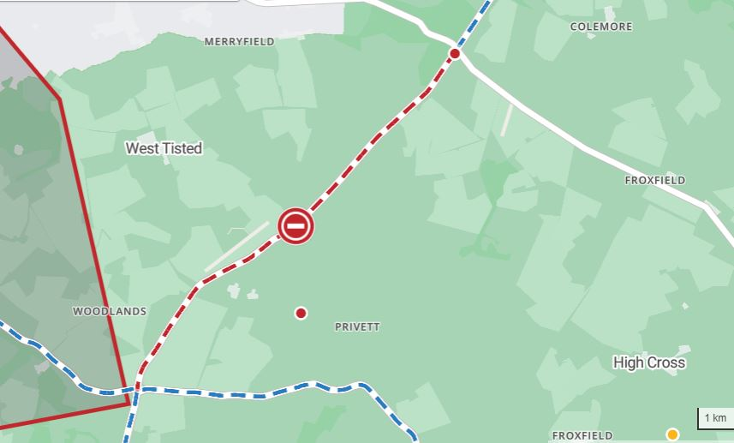

- School catering service: proposal to outsource

HCC is consulting schools and colleges on its proposal to terminate the in-house school meal service in 2026. The consultation started on 6 September and closes on 11 October. This is not a public consultation but I thought Parish Councils might want to be aware of it.

I am conscious that the proposal has created some concerns amongst smaller, rural primary schools. I would like to reassure everyone with concerns that no decisions have yet been made and we are listening. It is open to anyone to make a submission to the Decision Day of Cllr Steve Forster which I think will be in early December.

Education Catering, formerly known as HC3S, has experienced significant financial pressure in recent years due to the combined impacts of rising food and staff costs. To cover its costs, the Local Authority has needed to increase the price of its school meals above the funding rate provided by Government to schools. This has resulted in a loss of business and as such, the County Council can no longer continue providing a non-statutory in-house service in the long term without making a loss.

The consultation sets out two possibilities:

- For schools and nurseries to arrange their own catering provision. (There is an active, well-established private sector market of school food providers operating successfully in Hampshire, from which schools can select).

- To provide a managed outsource of the service which schools and nurseries could buy into. This option would see the County Council procure and manage the supply of meals from alternative providers, on behalf of schools and nurseries.

- HCC response to Planning Reforms consultation

The County Council has responded to the Government’s consultation on planning reform which includes proposed changes to the National Planning Policy Framework (NPPF). As part of efforts to tackle economic growth, the Government has targeted a number of planning issues in need or urgent reform. They propose raising the bar on delivery against nationally mandated housing targets which would see a 71% increase in the number of houses to be planned for annually across Hampshire. As well as the impact on housing growth across the County, the proposals also have implications for infrastructure delivery, education provision, specialist housing, transport planning, public health and climate change. Our response has set out the County Council’s position on each of these key strategic issues.

The key message is that the County Council responded in support of driving forward with growth, but warned against a standard methodology which fails to recognise local conditions and evidenced constraints – such as National Park designations – which make the increased housing numbers for Hampshire seem excessive and undeliverable. The lack of a transitional arrangement also undermines the plan-led system, resulting in planning authorities not being able to demonstrate a 5-year land supply and therefore opening the door for speculative applications and planning by appeal. The County Council expressed support for the reinstatement of strategic planning to unlock a sustainable level of plan-led growth in Hampshire, ensuring it is accompanied by necessary infrastructure.

In its response, the County Council has expressed concern that the proposed new standard method for assessing housing need results in much higher target numbers, which are overly
ambitious. The County Council does not support the revised targets across
Hampshire as they have been apportioned across local planning authority areas.
There are less constrained areas of Hampshire where housing markets are relatively
strong, and housebuilders are actively pursuing sites. However, in other areas, there
are challenges in translating allocations and planning permissions into dwelling
completions due to site viability, significant environmental designations, and
environmental issues such as nutrient neutrality.

The proposed 71% increase from the current methodology target is considered excessive and unreasonable, especially in the absence of strategic planning and without accounting for growth constraints. For instance, 45% of Hampshire is covered by various environmental designations, including National Parks, National Landscapes, and Special Protection Areas of
international significance.

I hope that Parish and Town Councillors are reassured that Hampshire County Council is standing up for Hampshire communities and for the environment in its response to the Government consultation.

RUSSELL OPPENHEIMER
County Councillor for Petersfield Hangers

