COUNTY COUNCILLOR REPORT
TO
ALL PARISH COUNCILS
IN PETERSFIELD HANGERS

1 DECEMBER 2024

- Hampshire Highways is ready for winter

With temperatures forecast to dip below freezing, our Highways teams and fleet of gritters are ready, day and night, to keep Hampshire’s main routes clear of ice and snow. They are also poised to respond to surface water flooding or fallen debris on the roads caused by heavy rainfall and high winds. All our gritters are fitted with the technology to ensure that we are salting in the right place and at the right time, including:

❄️ full satellite navigation guidance
❄️ an automatic salt delivery mechanism
❄️ dedicated snow plough equipment

‘Priority one’ routes, which carry most of Hampshire’s traffic, are always treated first, and include A-roads, some B-roads, access roads to hospitals and other key emergency hubs, large schools and colleges, and major bus routes. When icy or snowy weather is predicted to last, our ‘priority two’ routes – the remaining B roads and single access roads to villages – may also be treated.

Every year, our gritter drivers take refresher training, such as test drives and speed awareness, so that they can operate safely as they salt Hampshire’s priority routes. Gritters are not permitted to drive faster than 30mph, so please be patient if you find yourself travelling behind one of our gritters this winter.
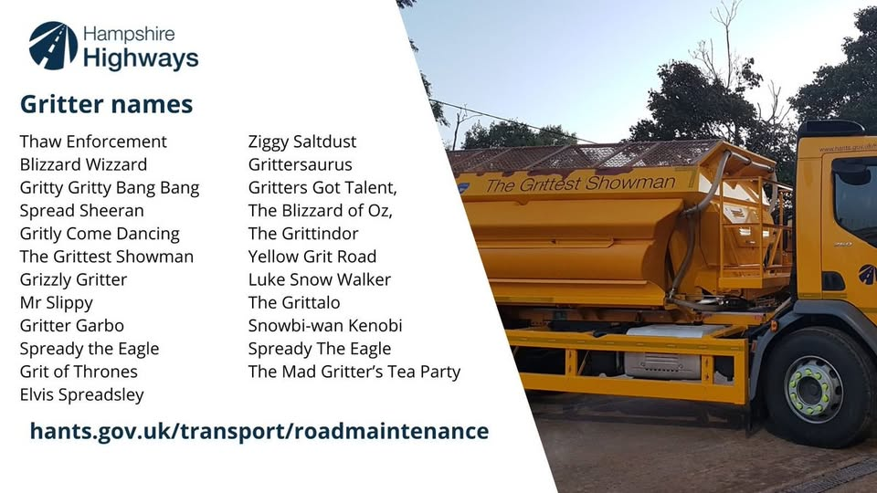
- Hampshire Cabinet backs farmers

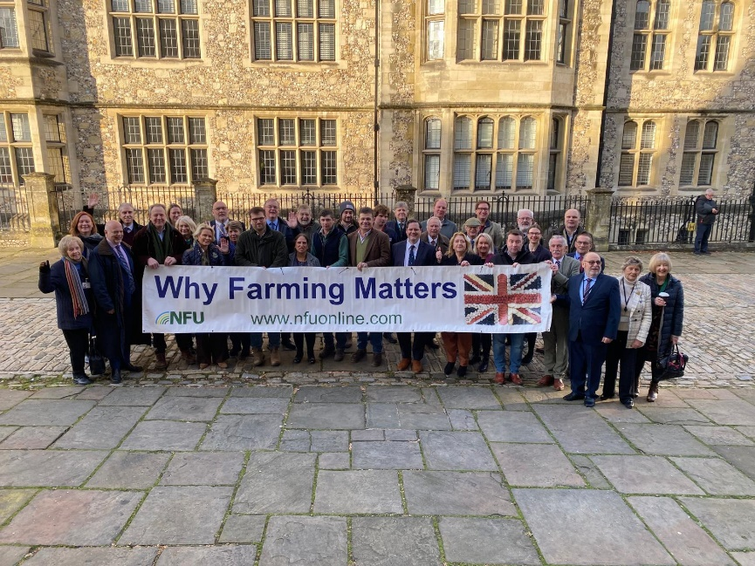

On Thursday 28 November Hampshire County Council’s cabinet met with farmers who had come to demonstrate about the Labour government’s Inheritance Tax changes that will land farming families with huge bills. Conservative councillors David Drew and Edward Heron tabled a motion in support of Hampshire farmers at a meeting of the Full Council.

Afterwards, they joined the Cabinet outside to meet with farmers, their families and NFU representatives to discuss the changes announced last month by the Chancellor Rachel Reeves.
She imposed a 20% inheritance tax on farms worth more than £1m from 2026-2027 through changes to Agricultural Property Relief. Farms were previously free of the tax.

The move could affect 2,500 farms a year, according to the Central Association of Agricultural Valuers, and not the 500 the government initially claimed. Council leader Nick Adams-King said: “Putting farming families, who have worked the land in Hampshire for centuries in some cases, under so much pressure when they are already struggling is completely wrong and will have consequences for our food security and our rural economy when farmers give up.”

The motion, which was passed with almost unanimous support, called on Council to:

- Request that the Leader writes to the Secretary of State for the Dept. of Environment, Food and Rural Affairs to outline the Council’s most serious concerns at this decision

- Ask the Lead Executive Member for Universal Services to engage with local farmers and community representatives to determine what action Council can take to support them

- Encourage all Members to sign the NFU petition calling for the overturn of the Family Farm Tax at: https://www.campaigns.nfuonline.com/page/160300/petition/, and to promote the petition within their divisions.

- Hitting the Cold Spots

As the temperatures drop, it is a good time to remind you all about the excellent Hitting the Cold Spots initiative run by Hampshire County Council. Hitting the Cold Spots helps Hampshire residents live more comfortably at home. The service specialises in home energy and has helped lots of residents access funding for boilers, hot water systems and even loft insulation. The service also provides tailored energy advice, unique to each caller’s situation. A dedicated energy adviser will check gas and electricity bills are help residents to resolve complex cases where necessary. Please help spread the word by linking to this web page:
https://hantscoldspots.environmentcentre.com/

- Rethink your drink

At HCC we recently held a Place Assembly on Alcohol Harm. Around 100 professionals from across the NHS, the voluntary sector and Local Government heard powerful testimony from people who have come very close to death as a result of alcohol addiction. The event gave me an insight into the profound harm which alcohol can do to individuals, families and society. I was also struck by the regular annual cost to the NHS of alcohol misuse. Alcohol misuse costs the NHS an estimated £3.5bn every year (according to the Public Accounts Committee).

What can we do about it? Collectively, we can take steps to avoid making individuals feel a sense of peer pressure and we can also normalise non-alcoholic options. With Christmas around the corner, we can all do our bit.

I would also like to draw attention to the Rethink your Drink web pages. These give some useful tips on how to handle drinking-related concerns. The pages also contain lots of links to free, effective resources across Hampshire. I will be very grateful for any support which Town and Parish Councils can give in promoting the Rethink your Drink web pages in newsletters and on social media please:
https://www.hants.gov.uk/socialcareandhealth/publichealth/alcoholawareness

- More Elm Trees available (disease-resistant ones)

Hampshire Forest Partnership still has funding available to supply different variants of disease resistant elms for free (bare root and pot grown).

Farmers and landowners are eligible to apply and can specify preferred tree sizes. The land need not be publicly accessible, but the Partnership prefers locations where people will be able to see the elms once they grow to maturity - for example in fields, hedgerows or boundaries viewable from a road, footpath or viewpoint.

The Elms prefer locations out of woodlands, and the trees must be allowed to grow to full maturity. Further information can be found here: https://www.hants.gov.uk/.../peopl.../disease-resistant-elms
Please contact treeplanting@hants.gov.uk for an application form.
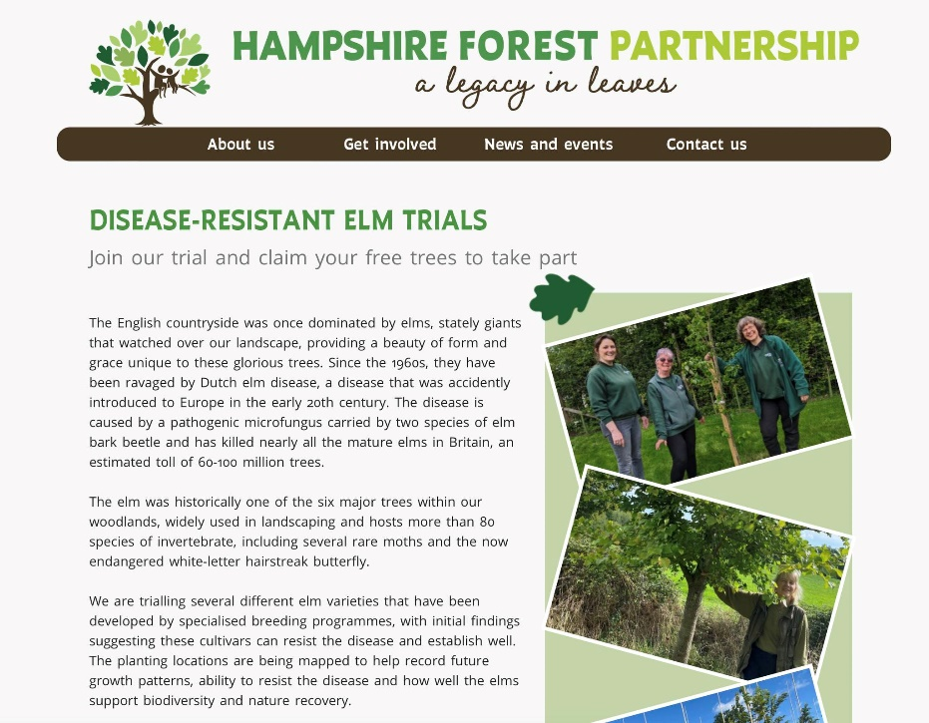

I should also like to mention that the South Downs National Park Trust has funding available for tree-planting too. Applications are open until March for funding bids for the 2025/26 planting season.

Here is a link to the relevant page of the South Downs National Park Trust website:
https://southdownstrust.org.uk/trees-for-the-downs-fund/

- Grants available to help people stop smoking

Grants of up to £50,000 each are available from HCC to support action to tackle smoking, from November 2024 to March 2028. The grant programme, with a total of up to £550,000 for district and borough councils and £300,000 for community groups, will be funded from the Local Authority’s ringfenced Public Health grant.

These grants underline our strong commitment to tackling the harm caused by smoking. They form part of our wider Smokefree Hampshire programme which aims to significantly increase the number of Hampshire smokers quitting each year by 2030, from the current 3,500, a year.
Smoking remains the single biggest preventable cause of ill health and premature death in England, costing the taxpayer millions and placing a huge burden on the NHS and social care. Therefore, helping people to quit smoking, as well as preventing them from starting in the first place, is absolutely vital.
With around 4,500 Hampshire residents dying each year, and a further 8,600 admitted to hospital due to smoking related problems, the County Council’s Smokefree programme includes collaborations with local GPs, hospitals, social housing and adult social care providers to boost referrals into the county’s free, expert-led quit smoking service - Smokefree Hampshire. The programme also includes outreach efforts, to engage with people who traditionally do not seek help from formal quit-with-support services.
- Petersfield Christmas Festival

Next weekend (Saturday 7 and Sunday 8 December) is the traditional Petersfield Christmas Festival with over 100 local stalls. The Festival this year will apparently be the biggest and best ever with music extended into the evening on Saturday night. I hope to see you there!

https://www.petersfieldfest.com/petersfieldchristmasfestival

RUSSELL OPPENHEIMER
County Councillor for Petersfield Hangers

