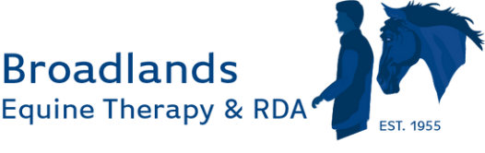

70th Anniversary Party Celebration
On Friday 20th June, with the support of many local companies, Broadlands celebrated its 70th anniversary with a party attended by 97 guests. The evening included a drinks reception with canapés, entertainment by a magician, dinner, dancing, and a fun casino. Over £7,200 was raised, allowing Broadlands to begin searching for a new pony to train to RDA standards, supporting the future of Broadlands Riding for the Disabled as some of their current ponies age.
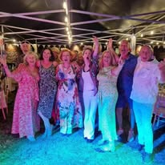
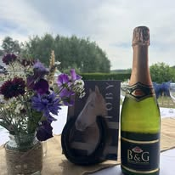

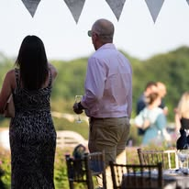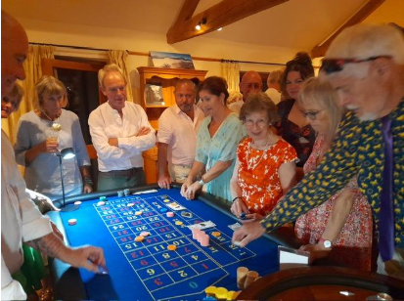

Since our recent celebrations, we've welcomed many new visitors to the stables. We hosted another Tea at Three, welcomed a local care home group, and enjoyed the Alton Victorian Cricket Day.
We took a team of participants to compete in the para ring at a local Fawley Farm Feeds show. Despite wet weather, everyone showed great enthusiasm and teamwork. Broadlands is proud of all the riders, horses, and helpers for their effort on what was a hugely successful day.
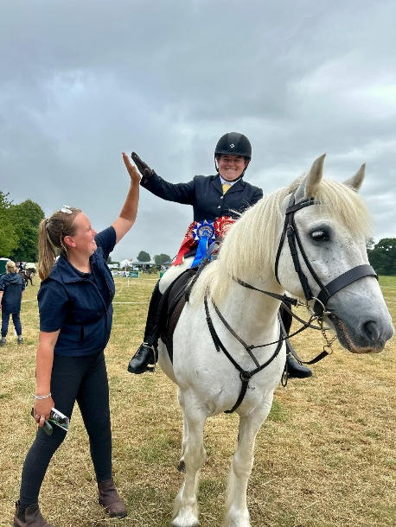
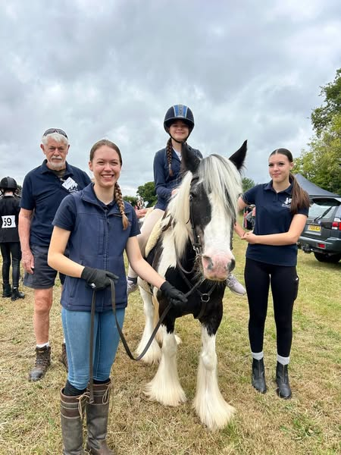

Upcoming events include the Medstead Fete and our Open Morning on Saturday 19th July from 11.00 – 2.00 p.m. where guests can meet ponies, watch participant demonstrations, enter a dog show, have a look at the stands and enjoy refreshments. Entry is free and everyone is welcome.
Please see our website for more information about Broadlands and our upcoming events:
www.broadlandsgrouprda.org.uk/events
