

We have had a very busy start to the Autumn as we welcomed back our local schools, regular and new participants and many visitors through our Tea with a Pony programme.
From Hay Nets to Sugar Rush!
What a month of weather roulette we've had. Not so long ago we were trudging out with armfuls of hay to keep the ponies happy as there was little grass ... ..now we're playing grass police. The autumn flush has hit hard, and the fields have turned into an all-you-can-eat buffet of high-sugar grass!
Our ponies are looking a little too pleased with themselves, so the grazing is now strictly rationed.
As if that wasn't enough, Mother Nature also decided to gift us a bumper crop of acorns. So, the oak trees in the big field are now officially off limits to our four legged friends.

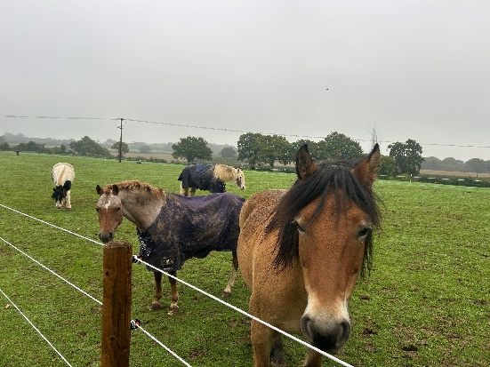

Wine Tasting
At the end of September, we enjoyed a wonderfully successful Wine Tasting Evening with Simon from The Naked Grape. Guests were welcomed with a sparkling wine on arrival, followed by five carefully selected wines — all vegan, to ensure everyone could enjoy the experience.
It was a fun, informative evening, and the wines were absolutely fabulous!

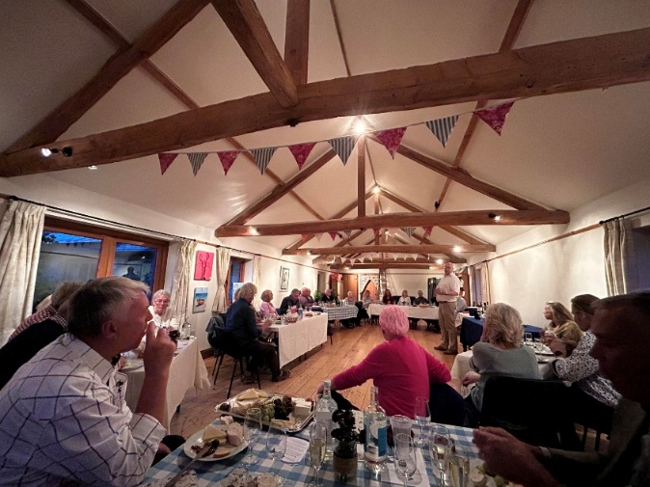

Trip to Liphook Equine Hospital
In early October, we organised a trip to Liphook Equine Hospital — and tickets sold out in record time! Those who attended had a fascinating visit. The hospital’s vets and nurses generously shared their expertise and guided us on an in-depth tour of the facilities.
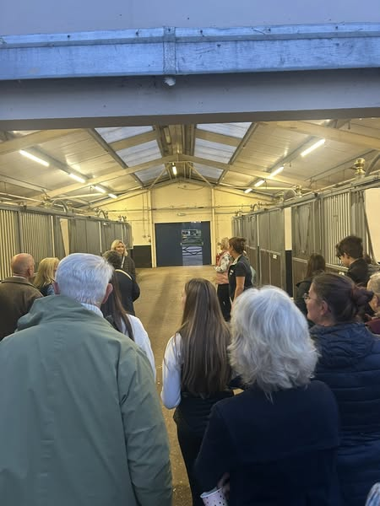

Celebrating 70 Years of Broadlands
This year marks our 70th Anniversary, and what a celebration it has been! At the start of the year, we set ourselves an ambitious goal — to raise an additional £30,000 on top of the £120,000 we need annually to run the charity.
Thanks to everyone’s incredible support — through events, donations, and even cake baking — we are delighted to say we’ve reached that target!
These funds have enabled us to purchase two of the ponies we hoped to add to our herd, and we’re now searching for a third. Next on the list: ensuring they have the right tack and receive full training.
A heartfelt thank you from our Trustees, Staff, & Volunteers— we couldn’t have done it without you.
2025 Christmas Cards
Our Christmas Card competition closed with a record number of entries this year. The four winning designs are currently with the printer and the cards will be on sale via our website within the next few weeks.
Upcoming Events
Broadlands 2025 Calendar of Events

Thursday 6th November | ROFGO Car Collection – Micheldever
Thursday 20th November | Christmas Canape Demonstration with Grassi and Jones
Sunday 30 November | Festive Wreath Making Afternoon
Friday 19th December | Carols at Broadlands
For more information on our forthcoming events or becoming a regular supporter please visit www.broadlandsgrouprda.org.uk.

