**COUNTY COUNCILLOR REPORT**

**TO**

**ALL PARISH COUNCILS**

**IN PETERSFIELD HANGERS**

**1 OCTOBER 2025**

1. Update on County Councillor Grant Scheme

On 24 September 2025, the HCC Cabinet approved the continuation of the grant scheme, but with some changes, to be phased in during 2025/26 and 2026/27. First, the good news, which is that the new scheme is opening today, 1 October 2025 and the hants.gov.uk web pages are now ready to accept applications.

One of the key changes is a reduction to the annual budget per Councillor from £8,000 to £5,000 which will be implemented immediately for the 25/26 grant window. This is a shame but, given the ongoing budget deficit, this is understandable. Officers actually recommended ceasing the grant scheme altogether but thankfully the Cabinet rejected this advice. The other approved changes are not too bad, in my view. I would like to draw your attention to these additional approved features of the new scheme:

* It has been agreed that the scheme will now include a maximum limit of £1,000 per application. Most Councillors had informally set this as their maximum limit anyway.
* Organisations cannot apply for grants over multiple years for the same purpose e.g. for the same event. Grant awards from the previous two years will be taken into account when applications are assessed.
* Grants will continue to be available for Parish Councils, however grants should not support normal business operation or projects that can be revenue funded or funded through alternative sources like the Community Infrastructure Levy.
* Grants for time-specific activities, such as seasonal events, must be awarded before the event takes place, otherwise they will be automatically rejected.
* All projects supported through the scheme must clearly acknowledge County Council funding in all promotional materials. Appropriate branding will be provided to partner organisations at the time funding is awarded, ensuring consistent and visible recognition of the Council’s contribution.

These changes will come into effect from today. The grant scheme will remain open until the end of March 2026. As I understand it though, in 2026, the grant window that year will run from June-December. In case you are interested to read more about this issue and the decision process, here is a link to the Decision report which Cabinet considered: [County Councillor Grants Review-2025-09-23-Cabinet](https://democracy.hants.gov.uk/documents/s138152/County%20Councillor%20Grants%20Review%20Report.pdf)

1. Cabinet changes

You may be aware from press reports that I stood down from the HCC Cabinet on 19 September 2025, and so I am now back to being a backbench Councillor. The reason for my resignation from Cabinet was primarily in order to have more time during the day to focus on my other commitments, including running a property company and training to be a languages teacher. I feel proud of many of my achievements during my five years in Cabinet, especially the creation of the Hampshire Forest Partnership and successfully saving the Petersfield tip from closure.

I still live in Petersfield and feel positive about the prospects for our area over the coming years. Devolution and LGR will bring more funding for infrastructure and regeneration projects. I remain 100% committed to my responsibilities as your local County Councillor, and I will continue to do my best to attend as many Parish Council meetings as I can. My successor as Executive Member for Health & Wellbeing is Cllr Stephen Reid and I wish him all the best.

1. Local Government Reorganisation -submission to Governnment

Following approval by the County Council’s Cabinet last week, Hampshire County Council has submitted its [preferred model for Local Government Reorganisation](https://www.hants.gov.uk/aboutthecouncil/governmentinhampshire/future-hampshire-solent/local-government-reorganisation/proposal) (LGR) to central Government.

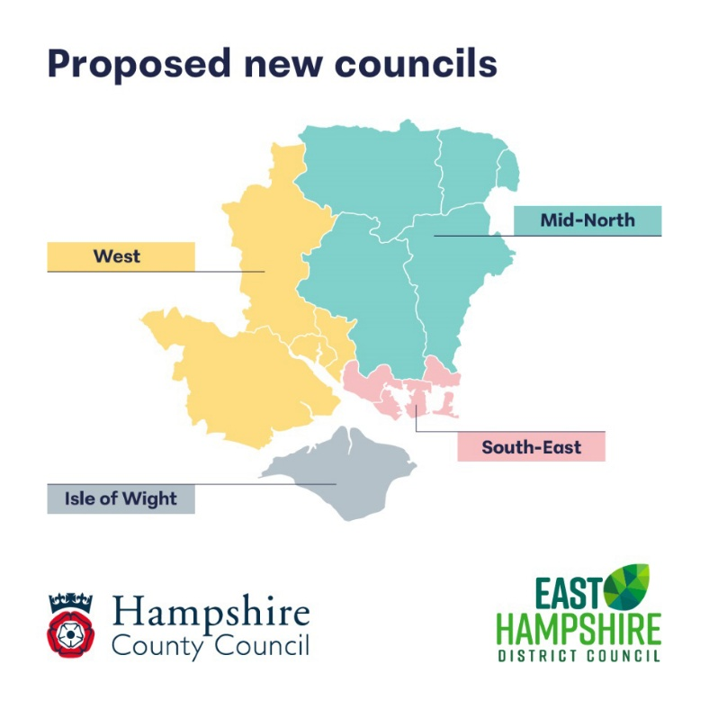

This proposal, developed in partnership with East Hampshire District Council, sets out our recommendation for the establishment of four new unitary authorities across the Hampshire and Solent area - three on the mainland and a separate unitary authority for the Isle of Wight. See above diagram.

Our aim is to create a simpler, stronger, and more secure system of local government in future, enhancing services and outcomes for residents and communities.

This submission represents a significant step forward in shaping the future of local government in our area. As set out in the timeline included in my September report, we understand that the Government will undertake a public consultation on proposals for local government reorganisation in our area later this year. Their final decision is expected next spring.

1. Highways Winter Service – changes to gritting routes

The Priority One salting network - which receives the most frequent winter treatments - has been comprehensively reviewed to ensure it fully aligns with national guidance. Over time, the previous Priority One network had grown in a piecemeal way leading to inconsistencies, with some roads routinely treated that no longer meet the policy criteria. The review that has been undertaken by officers has adopted a robust, evidence-based approach that fully meets national guidelines and best practice. As a result, the Priority One network will be reduced in length with some roads moved to the new Priority Two Community Route network. These changes will help the County Council make savings on vehicles, salt, and operational resources.

Improved weather-forecasting tools are also being introduced that will allow the Highways Team to more effectively and efficiently target those areas that are expected to freeze. This will reduce the number of unnecessary treatments (where roads remain above freezing), reduce carbon emissions, and will also free up staff resources to focus on other essential frontline tasks such as pothole repairs.

A new combined Priority Two and Community Route network will be introduced at a later date that will include roads removed from the Priority One network as well as routes serving more schools, additional bus routes, and access roads to more residential areas. This change also follows national guidance, which recommends maintaining either a secondary or community network, but not both.

There will continue to be a large stock of community grit bins across the network for roads that are not routinely gritted. However, the way salt bins are managed will also be changing. Of the 4,000 bins currently in place, around 500 have not been used since 2017. These will no longer be maintained going forward and will eventually be removed. Previously, all the bins were inspected and refilled annually by an external contractor. From now on, the inspections will be carried out by our own Highways Team and bins will only be refilled when they are less than half full. Requests from the public and parish/town councils to refill bins will still be fulfilled.

Ahead of the coming winter season, the County Council’s website will be updated with new maps and travel advice, and information will also be shared via social media. Details of the new Priority One salting network can be found on the following link: [Road salt (grit) bins | Hantsweb](https://eur02.safelinks.protection.outlook.com/?url=https%3A%2F%2Fmaps.hants.gov.uk%2Fhighwayssaltroutes%2F&data=05%7C02%7CRussell.Oppenheimer%40hants.gov.uk%7C3f393b67ef7f48c3275608dde55f4697%7C3f81d8b5ee074c17869c1db439018d9b%7C0%7C0%7C638918919574349777%7CUnknown%7CTWFpbGZsb3d8eyJFbXB0eU1hcGkiOnRydWUsIlYiOiIwLjAuMDAwMCIsIlAiOiJXaW4zMiIsIkFOIjoiTWFpbCIsIldUIjoyfQ%3D%3D%7C4000%7C%7C%7C&sdata=4vmHWejtGdcYUn8M9y6LlJpPRMbuILkRnTTjvhuBdek%3D&reserved=0)

I appreciate that any change to frontline services can raise concerns. However, the financial pressures we face at HCC mean that we must continually review how we deliver all our services so that we can continue to ensure that we meet our core statutory duties. These changes will allow us to maintain an effective winter service that reflects national best practice and will ensure that we continue to meet our obligations under the Highways Act.

**RUSSELL OPPENHEIMER**

**County Councillor for Petersfield Hangers**