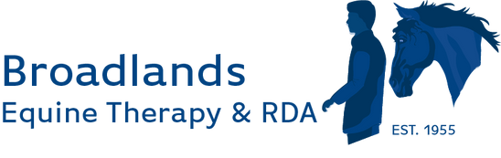

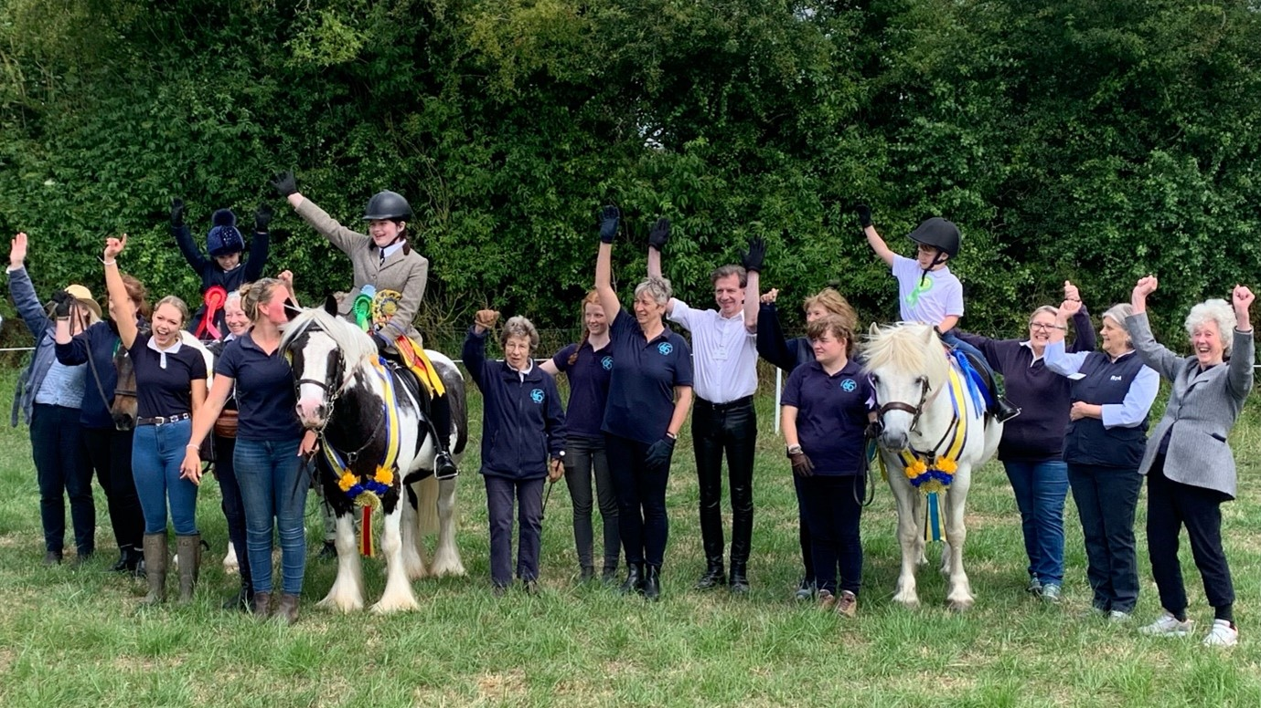

We Did It!
At the start of 2025 we pledged to raise an extra £30,000 in celebration of our 70th anniversary year — and thanks to your generosity, we reached £31,500! This wonderful achievement has already enabled us to buy two of the three ponies we hoped to welcome into our herd, and we’re still keeping our eyes open for the third. Our heartfelt thanks go to everyone who contributed and supported us along the way.
Looking Ahead to 2026
Plans for our 2026 events are already underway. Our annual quiz night, wine-tasting evening, the Wivelrod Barn talks, and even next year’s wreath-making afternoon are all beginning to take their place in the calendar.
We’d also love to hear from you if you have contacts who might make inspiring speakers for our Wivelrod talks, or if you have any fresh fundraising ideas. Please get in touch with Kim at kim@broadlandsgrouprda.org.uk.
As we write, the ponies are looking forward to a well-earned rest over the festive season. They’ll be back in early January, ready to welcome both familiar and new faces—whether for regular riding sessions or simply to spend time on the yard grooming, feeding, and enjoying the peaceful, caring environment that makes Broadlands so special.
For us—staff, trustees, and volunteers alike—the end of the year is also a chance to pause. And it’s made even more meaningful when we open an email like this one from the family of a participant:
“My daughter began her time with Broadlands * months ago and in that time has grown and flourished.
The gentle, warm approach, tranquil yard and calm pace have provided a safe space for her to develop new skills and confidence. With the right support and understanding, she has discovered a passion for learning and is once again able to absorb and put into practice new skills at the yard. New opportunities have opened up, and a desire to work towards a future career has been made possible by Broadlands.
Paige and the team of staff, trustees and volunteers are true heroes in our eyes for making this possible.”
May we take this opportunity to thank everyone for their support throughout 2025. We wish you all a very happy and healthy New Year!

