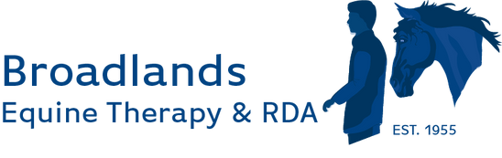

Broadlands New Year Newsletter 2026

Happy New Year from Broadlands
A very happy New Year to you all from everyone at Broadlands Equine Therapy & RDA!
Here at Broadlands, we are very much looking forward to 2026. We have already welcomed some new participants, including young people from a local school, and it has been wonderful to see many of our regular participants return. They were clearly delighted to be back and very eager to see the ponies again!

Pony News 🐴
Our ponies certainly enjoyed their well-deserved rest over the festive period. Since the New Year, however, they have had to endure some cold, frosty nights, which they seem largely unfazed by! That said, with the weather changing almost daily, we suspect they may be just as confused by it as we are.
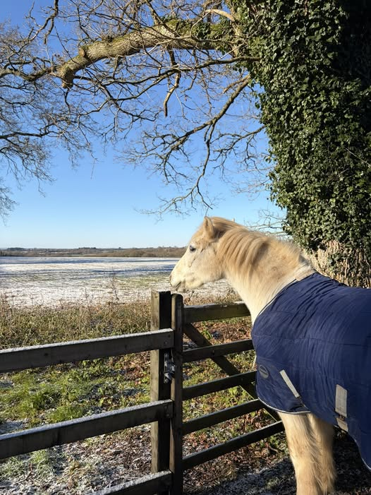
Creagy enjoying the crisp clear blue skies whilst wrapped up in his warm rug!
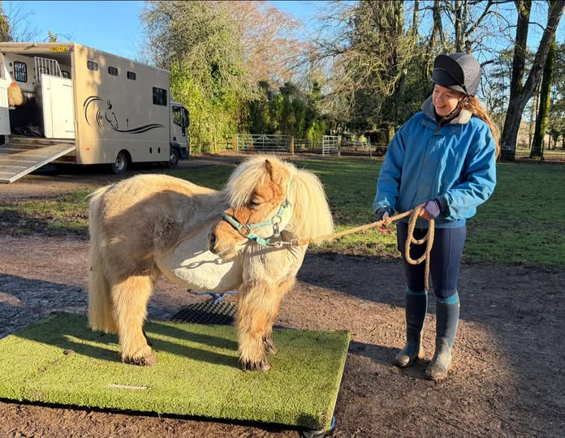
The ponies have all been weighed to check their post Christmas pounds! Kingsley seems comfortable on the scales. The ponies are regularly weighed to ensure we are keeping them in tip top condition!

Fundraising Events – 2026
We are excited to be developing a diverse programme of fundraising events for the year ahead and hope you’ll come and join us.
Alongside raising much-needed funds to support our work, these events are a fantastic opportunity to connect with like-minded supporters and enjoy a series of engaging talks and activities throughout 2026.



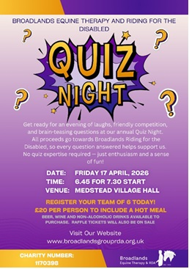

We Hope to See You There!
Thank you, as always, for your continued support of Broadlands Equine Therapy & RDA. We look forward to another positive and rewarding year together.
If you have any queries, please do not hesitate to contact us:
📧 office@broadlandsgrouprda.org.uk

