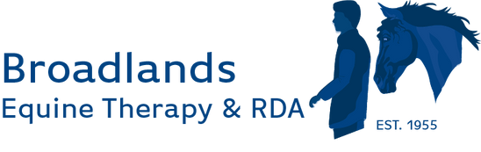

Broadlands April Newsletter 2026

Pony News 🐴

Broadlands Open Day – Saturday 2nd May
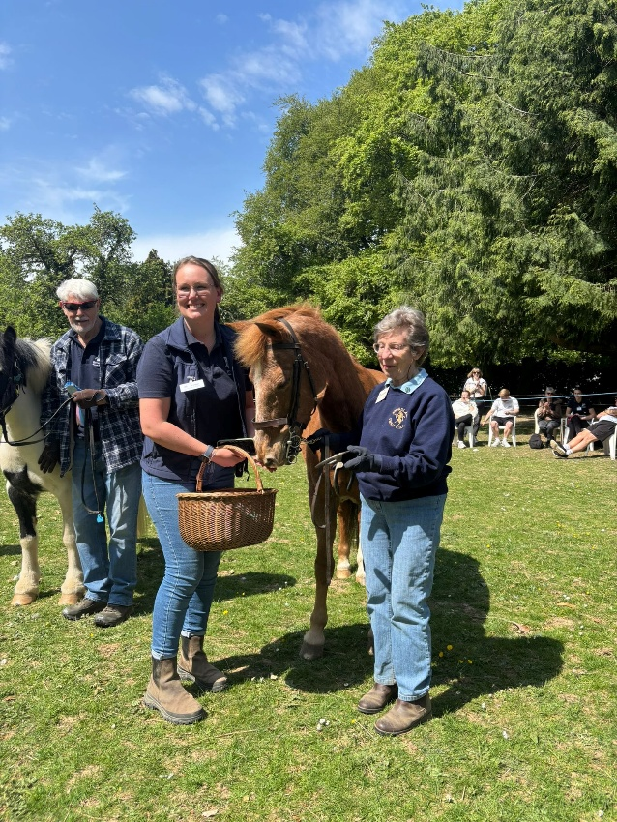
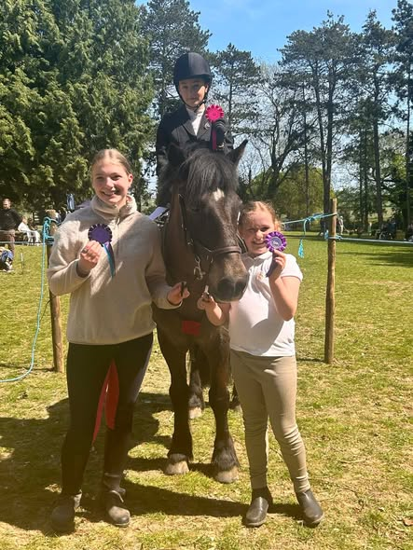
Paige, our Centre Manager, presents Suzanne with a special award. Suzanne has recently retired as a Trustee after over 60 years of involvement with Broadlands! Michael (in the background) received the Volunteer of the Year Cup!
Three of our young participants enjoyed showcasing their skills on Saturday. They have all come such a long way and we are very proud of their achievements.

We were delighted to welcome so many visitors to our annual Open Day. The displays in the main arena highlighted the remarkable progress our participants have made through their lessons. It was a joy for parents, carers, friends, and members of the local community to see these achievements firsthand and to witness the special bond shared with our wonderful ponies.
The BBQ was in full swing, the kettle never stopped boiling, and there was an abundance of cakes for everyone to enjoy. A variety of side shows kept visitors entertained throughout the day, with the hobby horse obstacle course proving especially popular.
We also received a record number of entries for the fun dog show, making it a busy and challenging morning for our judges!

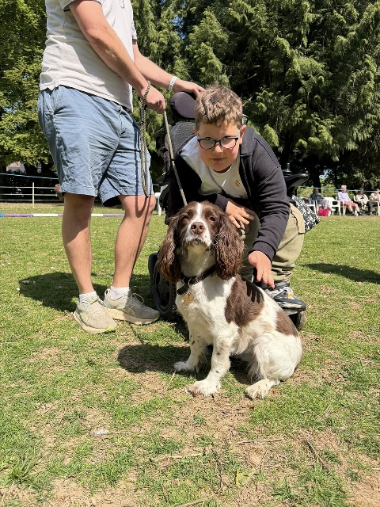

Quiz Night
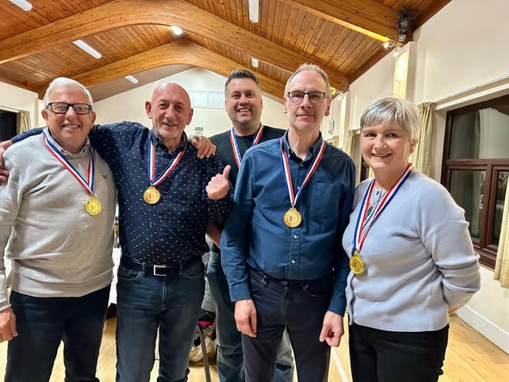
Over 70 people turned out to support our annual Quiz Night at the end of April. A hot supper, a busy bar and lots of comradery made for a fun evening. The ‘Odd Jobbers’ were our winning team, made up primarily from the Broadlands volunteer maintenance team.
Well done to everyone who supported us and helped raise £1,800!

South Region RDA Conference

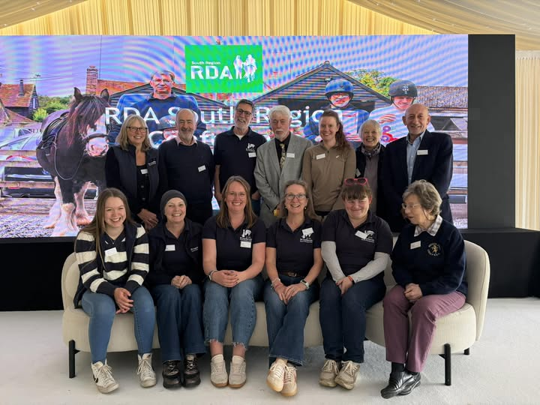
A team of 13 of us headed off to the South Region RDA Conference, the first one for 9 years. It was an informative, inspiring and fun day for us all. The team was made up of Trustees, Staff and Volunteers and proved to be an extremely interesting day out!

Visit to Park House Stables, Kingsclere

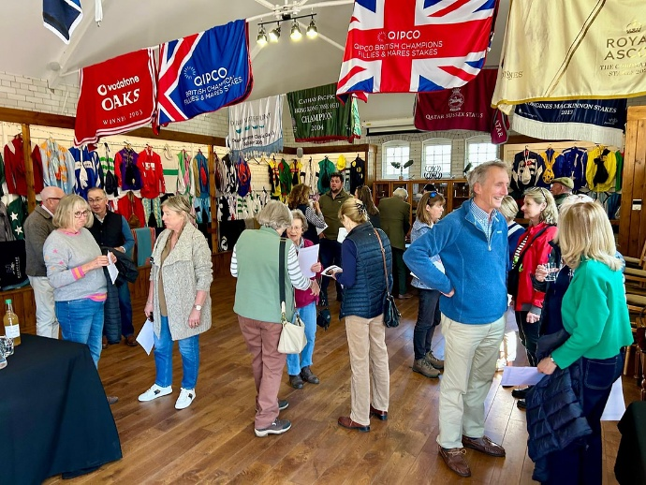
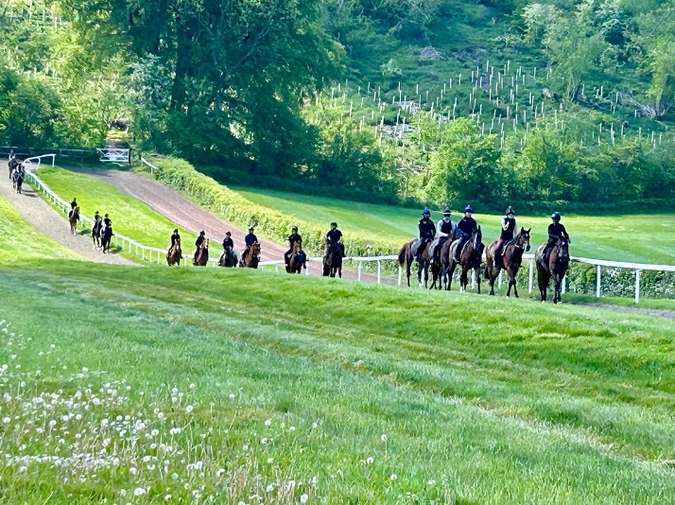

We were delighted to enjoy a wonderful fundraising morning at Park House Stables. Guests were welcomed with coffee and cake before being driven up to the gallops, followed by the opportunity to meet some of the magnificent horses that call the stables home. Our sincere thanks go to Andrew and Anna Lisa Balding and their staff for their warm hospitality and for allowing us to experience such a beautiful and special place.

