Upcoming Events –
We hope you can join us for our Summer Wine Tasting and for our next Tea at Three.
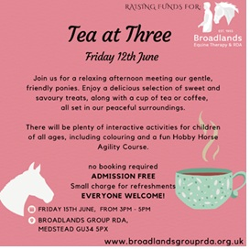

We Hope to See You There!
Thank you, as always, for your continued support of Broadlands Equine Therapy & RDA.
If you have any queries, please do not hesitate to contact us:
📧 office@broadlandsgrouprda.org.uk

