

Broadlands June Newsletter 2026

Pony News 🐴

We have a new pony – Jigsaw has arrived!
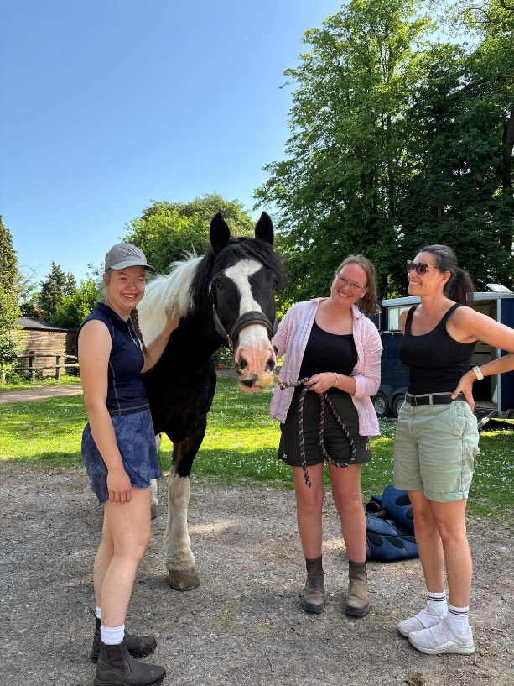
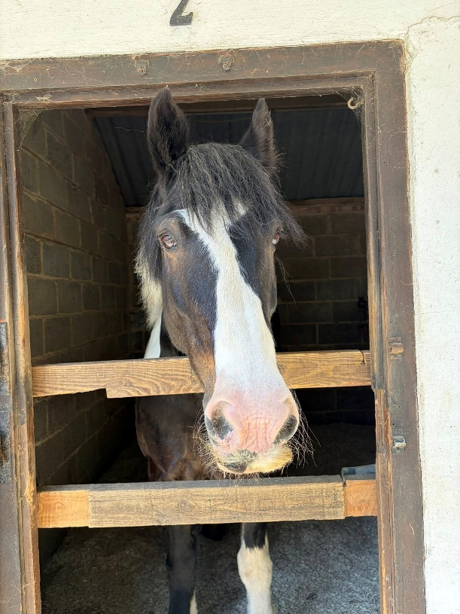
We are delighted to have welcomed Jigsaw to Broadlands. We had been searching for a slightly larger pony, and our patience has certainly paid off.
Jigsaw is very relaxed and appears to have settled into the yard remarkably quickly. For the first couple of weeks, he was turned out in adjacent fields to the rest of the herd, but he has now joined Rocky in the field and they seem very happy together. Over the coming weeks, we will gradually introduce him to the other horses he will eventually be turned out with.
He is wonderfully calm in the stable and enjoys plenty of fuss and cuddles. Paige and Freya have already started working with Jigsaw and are absolutely delighted with him.

Upcoming Events –
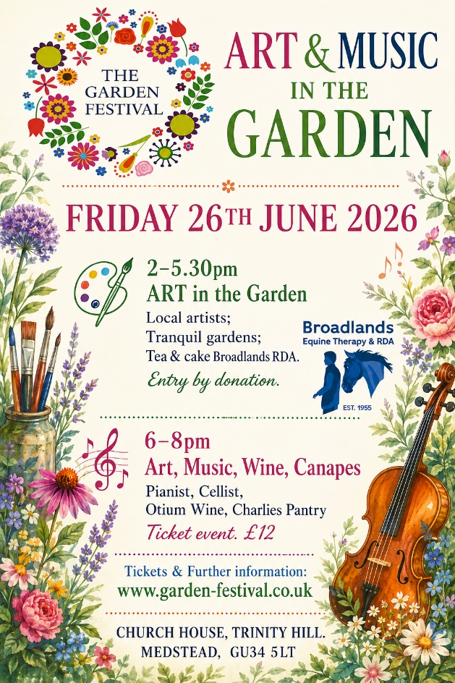
We hope you can join us for our Summer Wine Tasting and enjoy Tea and Cake as part of the Garden Festival, at Church House, Medstead.


We Hope to See You There!
Thank you, as always, for your continued support of Broadlands Equine Therapy & RDA.
If you have any queries, please do not hesitate to contact us:
📧 office@broadlandsgrouprda.org.uk

